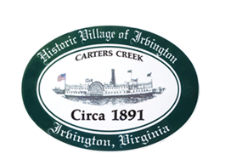

**THE TOWN OF IRVINGTON**

**PLANNING COMMISSION REGULAR CALLED MEETING**

**Irvington Town Office, 4203 Irvington Rd., IRVINGTON, VA**

**TUESDAY, January 2, 2024; 6:30PM**

**Preliminary Agenda**

1. **Call to Order –** *T. Chapman*
2. **Roll Call and Determination of Quorum –** *T.* *Chapman*
3. **Approve Minutes**

* 11/8/2022 Minutes approval – *T. Chapman*

1. **Report From Chair-** *T. Chapman*

* Town Hall- Museum Plan/Tides Cup/PC suggested Code changes/County Public Water Access

1. **Public Comment**
2. **Report from Zoning Administrator –** *Justin Nelson*
3. **Old Business**
   1. **ADU etc–** *A. Pollard Jr and R. Fuller*
   2. **Comprehensive Plan Update –** *T. Chapman*
   3. **Sign Ordinance Amendment** *– D. Clarke/J. Taylor*
4. **New Business**
   1. **CUP neighbor letters –** *J. Nelson*
   2. **Year End PC Report –** *T. Chapman*
5. **Next meeting**

January ?, Joint PC?TC Public Hearing on Draft Comprehensive Plan

January ?, Joint PC/TC Workshop on Draft Comprehensive Plan

Feb 7, 2023, at the Irvington Town Hall or Irvington Baptist Church, 6:30 p.m.

1. **Adjourn**