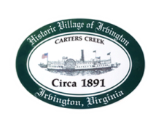
Town of Irvington Zoning Administrator Report
Prepared for Planning Commission
Prepared For: August 2nd, 2022
Staff Contact: Justin Nelson, Zoning Administrator

Zoning Permits

2022-11, 2022-12 removal of dead/dying trees in RPA

Miscellaneous

Site visit to Fisher’s Pitt w/MME representative, slow steady progress; site visit to 277 Steamboat for remodeling project, no application made; site visit for abandoned cars on Edgewood Ln, tenant has until 8/3/2022 to remove; site visits to neighbors of Tides Inn for inspection/discussion of their property as relates to new Tides application; tours of Tides Inn w/planning commission and town council members.
Tides Inn has submitted CUP for extensive renovation, app # 2022_CUP01TIDES

.

