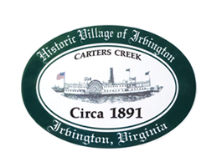
Permit#_______________________________
Date_____________________
Tree Removal Permit Application

Town of Irvington, Virginia, Code of Ordinances PERFORMANCE STANDARDS as defined in Sec. §154.153 (B)(2)(a); Existing trees over six inches in diameter at breast height (DBH) shall be preserved outside the construction footprint. Diseased trees or trees weakened by age, storm, fire or other injury may be removed when approved by the Zoning Administrator.

__________________________________________________________________________________
Applicant Name Name of Property Owner (if different)

__________________________________________________________________________________
Property Location

__________________________________________________________________________________
Applicant Contact Information Email Home Phone Mobile Phone

__________________________________________________________________________________
Tax Map Parcel Number Zoning Classification

CONDITION OF TREE(S) TO BE REMOVED

□ Diseased □ Damaged □ Dead □ Over Hanging

NATURE OF APPLICANT:

□ Business □ Church □ School □ Non-Profit  □ Residence

___________________________________________________________________________________
Tree Location(s)

___________________________________________________________________________________
□ N □ E □ S □ W Side of State Road # (i.e. Route 200) Nearest Cross Street

__________________________________________________________________________________
Applicant (s) Signature

For Office Use Only
  □ Approved □ Disapproved ____________________Permit Number

_______________________________________________________________________________________________
Reason
_______________________________________________________________________________________________
Town Administrator/Zoning Official Date

