TOWN OFFICIALS

Julie Harris
Mayor

Andrew McRoberts.
Town Attorney

Justin Nelson
Zoning Administrator

Laurel Taylor
Town Clerk

TOWN COUNCIL

Judy Penniman

Jackie Brown

Bonnie Schaschek

R. Wayne Nunnally

Gabe Del Rio

Dudley Patteson

Town of Irvington

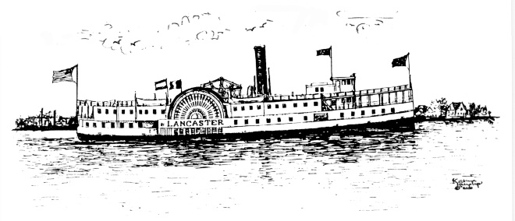

August 17th, 2022

ZONING ADMINISTRATOR’S SUMMARY OF CITIZEN LETTERS ON TIDES INN CUP APPLICATION # 2022.CUPTIDES

The zoning administrator has received four letters from surrounding property owners on King Carter and Lancaster Drive, and offers this summary of main issues:

- All bamboo is to be completely remediated, including on the Hall property at 650 King Carter Drive
- A buffer of trees planted between Hall property and install a sound dampening 10’ fence on Tides property to shield said fence, prior to construction beginning
- VDOT report on the two new proposed entrances/exits be submitted prior to Town government vote on the application
- Re-locate proposed new service road on King Carter to a wider part of King Carter

Please let me know any questions.

Justin Nelson
Zoning Administrator
Town of Irvington

