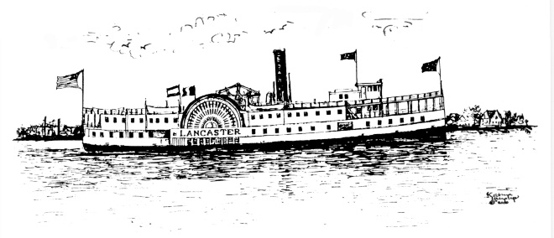

TOWN OF IRVINGTON
MEALS TAX MONTHLY REPORT

Business Name: __________________________________________________________

RESTAURANT address:

Please indicate the month
□JAN □ FEB □ MAR □ APR □ MAY □ JUN □JLY □AUG □SEPT □OCT □NOV □ DEC

- Gross sales subject to Irvington Meals Tax $______________

- Total tax owed (multiply line 1 by 0.03) $______________

- Penalty, if paying after the 20th of the following month (Multiply line 2 by 0.05) $______________

- Total tax and penalty owed. Add lines 2 & 3 $_____________

I hereby swear or affirm that the amounts listed above are true, correct, and complete to the best of my knowledge and belief for the period stated above.

Signature Title Date

Address if other than RESTAURANT Phone Email

INSTRUCTIONS: Mail original copy with check payable to the Town of Irvington on/or before the 20th day of the month following the month being reported:
Town Clerk
PO Box 174
Irvington, VA 22480
For Office Use Only
Date Rec’d___________________________________Check#___________________________________

