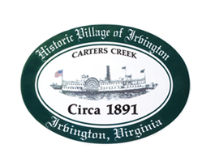

**THE TOWN OF IRVINGTON**

**PLANNING COMMISSION REGULAR CALLED MEETING**

**Irvington Town Office, 4203 Irvington Rd., IRVINGTON, VA**

**TUESDAY, March 5, 2024; 6:30PM**

**Preliminary Agenda**

1. **Call to Order**
2. **Roll Call and Determination of Quorum**
3. **Approve Minutes**

* 2-6-24 Minutes approval

1. **Report From Chair-** *T. Chapman*
2. **Public Comment**
   1. Knisley STR CUP
   2. Other Public Comment
3. **Report from Zoning Administrator –** *Justin Nelson*
4. **Old Business**
   1. Accessory Dwelling Units – A. Pollard Jr.
   2. Sign Ordinance Amendment Status*– D. Clarke/J. Taylor*
   3. Fence Ordinance
5. **New Business**
   1. VDOT Review of Transportation Section of Comprehensive Plan
   2. Capital Improvement Plan
6. **Next meeting**

March 5, 6:30, PC Monthly Meeting at Irvington Town Hall

March 12, Joint PC/TC Workshop 5:30pm at IBC

March 14, Joint Public Hearing on Redfish CUP

1. Roundtable
2. Adjourn