TOWN OFFICIALS

Julie Harris, Mayor

Justin Nelson
Zoning Administrator

Laurel S. Taylor
Town Clerk
FOIA Officer

Sands Anderson
Town Attorney

TOWN COUNCIL

Judy Penniman

Jackie Brown

Bonnie Schaschek

R. Wayne Nunnally

Anthony Marchetti

Dudley Patteson

Town of Irvington

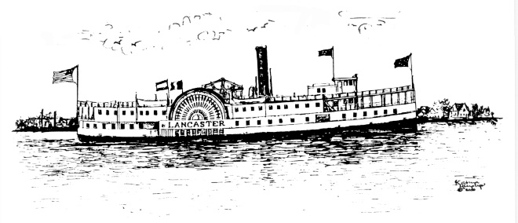

TOWN OF IRVINGTON
OCCUPANCY TAX MONTHLY REPORT

NAME OF BUSINESS IRVINGTON ADDRESS OF RENTAL
Please indicate the month
□JAN □ FEB □ MAR □ APR □ MAY □ JUN □JLY □AUG □SEPT □OCT □NOV □ DEC

- Total lodging charges subject to tax $______________

- Tax remitted on your behalf from: Online platform/intermediary
_______________________ $______________ $_______________
Platform(s) Gross Receipts Tax paid on your behalf

- Complete this line: Bed & Breakfast $_____________ Tents $________________

- Tax on Lodging 4% of line 1 $______________

- Penalty – 10% $_______________

- Interest $_____________

- Total Amount Due $_____________

- Total Amount Due if After Due Date $______________

I hereby swear or affirm that the amounts listed above are true, correct and complete to the best of my knowledge and belief for the period stated above.

Signature Title Date

Address if other than rental property Phone Email

INSTRUCTIONS: Mail original copy with check payable to the Town of Irvington on/or before the 20th day of the month following the month being reported:
Town Clerk
PO Box 174
Irvington, VA 22480
For Office Use Only

Date Rec’d___________________________________Check#___________________________________

