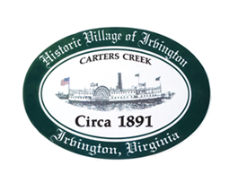
TOWN OF IRVINGTON, VIRGINIA
IRVINGTON BAPTIST CHURCH
TOWN COUNCIL SPECIAL CALLED MEETING/WORKSHOP
THURSDAY, AUGUST 26, 2021, 5:00 p.m.

AGENDA
- CALL TO ORDER – Mayor Westbrook

- ROLL CALL

- APPROVE AGENDA

- TOWN COUNCIL RETREAT DISCUSSION

- WORKSHOP: Discussion of vacant position, Town Attorney

- ADJOURN

