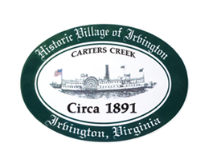

THE TOWN OF IRVINGTON
IRVINGTON BAPTIST CHURCH, IRVINGTON, VA
BUDGET & FINANCE WORKSHOP
Thursday, May 11, 2023; 5:30PM

AGENDA

- CALL TO ORDER – J. Harris

- ROLL CALL OF TOWN COUNCIL

- APPROVAL OF AGENDA

- DISCUSSION OF OPERATING BUDGET

- DISCUSSION OF CAPITAL IMPROVEMENTS BUDGET

- ADJOURNMENT

