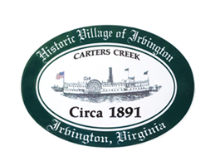

The Town of Irvington Planning Commission
Regularly Called Meeting September 7th, 2021, 6:30PM
Irvington Town Office
4203 Irvington Road, Irvington, VA 22480

1. Call to order - Julie Harris, Chair
2. Roll Call and Determination of Quorum- Julie Harris, Char
3. Approve Minutes
1. July 13th, 2021 Special Called Meeting
4. Report from Chair – Julie Harris
5. Report from Zoning Administrator – Justin Nelson
6. Old Business: Update on proposals of development for Town Survey—J Harris
7. New Business
1. First reading of Resolution for rezoning application #2021.RZ1 Pollard, 73 Seafood Lane, Irvington, VA 22480; tax map 33.379 to rezone from M-1 to B-1

2. First Reading of Resolution for Conditional Use Permit application #2021.CUP_POLLARD 73 Seafood Lane, Irvington VA 22480; tax map 33.379 for an Inn in B-1

8. Next meeting: Tuesday, October 12, 2021 at 6:30 at Irvington Baptist Church.
1. This meeting will be a Special Called
Meeting.
2. This meeting will be a Joint Public
Hearing with Town Council to hear
Public Comment on the above 2
Resolutions.
3. Due to the outbreak of the Delta variant
of the Covid-19 virus, the November and
December Planning Commission
meetings (November 9, December 14)
will be Special Called Meetings at 6:30 at
Irvington Baptist Church to allow for
greater social distancing.

9. Adjourn

