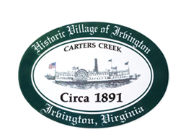

THE TOWN OF IRVINGTON
PLANNING COMMISSION REGULAR CALLED MEETING
IRVINGTON TOWN OFFICE, 4203 IRVINGTON RD., IRVINGTON, VA
TUESDAY, April 5, 2022; 6:30PM

- Call to order – Tom Chapman

- Roll Call and Determination of Quorum- T. Chapman

3. Approve Minutes
- 3/1/2022 Minutes approval – T. Chapman

- Report from Chair – Tom Chapman

- Public Comment

- Report from Zoning Administrator – Justin Nelson
- Monthly Report

- Old Business
- Sewer Advisory Panel Update – T. Chapman
- Discussion of Town Survey Questions – Brian Forrester

- New Business
- Next meeting
- May 3, 2022, at the Town Office
9. Adjourn

