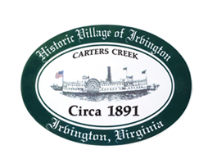

THE TOWN OF IRVINGTON
PLANNING COMMISSION REGULAR CALLED MEETING
IRVINGTON TOWN OFFICE, 4203 IRVINGTON RD., IRVINGTON, VA
TUESDAY, August 2, 2022; 6:30PM

Preliminary Agenda

- Call to order – Ruth Fuller

- Roll Call and Determination of Quorum- R. Fuller

3. Approve Minutes
- 7/5/2022 Minutes approval – R. Fuller

- Report from Chair – R. Fuller

- Public Comment

- Report from Zoning Administrator – Justin Nelson
- Monthly Report

- Old Business
- Town Survey status and plans – R. Fuller
- Tides Inn CUP status – J. Nelson

- New Business

- Next meeting
Sept 6, 2022, at the Irvington Baptist Church at 5:30 p.m. for a Joint Public Hearing immediately followed by the Planning Commission Regular Called Meeting
9. Adjourn

