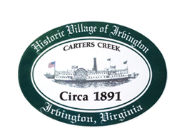

THE TOWN OF IRVINGTON
PLANNING COMMISSION REGULAR CALLED MEETING
IRVINGTON TOWN OFFICE, 4203 IRVINGTON RD., IRVINGTON, VA
TUESDAY, March 1, 2022; 6:30PM

- Call to order – Tom Chapman

- Roll Call and Determination of Quorum- T. Chapman

3. Approve Minutes
- 2/1/2022 Minutes approval – T. Chapman

- Report from Chair – Tom Chapman

- Public Comment

- Report from Zoning Administrator – Justin Nelson
- Monthly Report
- report on number of STRs registered with the Town and 2021 tax collections

- Old Business
- Status Report on Town Survey- Brian Forrester
- Discuss Designated Outdoor Refreshment Area Status – A. Pollard
- Sewer Advisory Panel Update – T. Chapman

- New Business
- Comments on Lancaster County rezoning on RT 200 – A. Pollard
- STR Committee update – P. Robinson
- Next meeting
- April 4, 2022, at the Town Office
9. Adjourn

