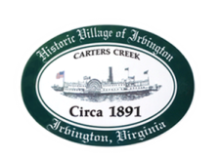
Town of Irvington Zoning Administrator Report
Prepared for Planning Commission & Town Council
Prepared For: June 2023 Regularly Scheduled Meetings
Staff Contact: Justin Nelson, Zoning Administrator

Zoning Permits:

#2023-16, new house tax map #33-254 & 33-254A; 2023-17 dead tree in RPA; 2023-18 replace dock on Cedardale Lane; review new home application on Old Mill Cove with PC
An STR CUP for York road and a CUP for redevelopment in the RPA have been received

Miscellaneous:
Additional receipts received from Mr Fisher for removal of debris; site visit to 277 Steamboat for driveway access; site visit to tap map 33-238 for new house and tree work; Sidewalks on Steamboat are now done, thank you to citizens who were inconvenienced working with the Town.

