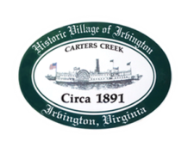
Town of Irvington Zoning Administrator Report
Prepared for PC/TC joint meeting
Prepared For: September 6th, 2022
Staff Contact: Justin Nelson, Zoning Administrator

Zoning Permits

2022-13, swimming pool 932 King Carter; 2022-14, renovations to 277 Steamboat
CUP application # 2022.CUP73Cafe for outdoor café at 73 Seafood Lane

Miscellaneous

Received additional receipts for debris removal at Fisher’s Pitt; site visit to Saunders property for redevelopment meeting; Gas pumps will re-open, market building will receive extensive renovations to become an upscale market, no time frame available at this time; meetings with Tides Inn representatives and Ms Elliott to attempt a consensus; served violation notice for abandoned cars on Edgewood Ln, they are gone

.

