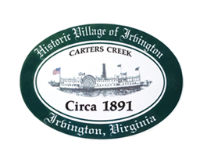

THE TOWN OF IRVINGTON
PLANNING COMMISSION REGULAR CALLED MEETING
IRVINGTON TOWN OFFICE, 4203 IRVINGTON RD., IRVINGTON, VA
TUESDAY, JANUARY 4, 2022; 6:30PM

- Call to order – Tom Chapman, Vice Chair
(Swearing in of Ruth Fuller by Mayor Harris)

- Roll Call and Determination of Quorum- T. Chapman, Vice Chair

3. Approve Minutes
- December 7, 2021

- Report from Vice Chair – Tom Chapman

- Report from Zoning Administrator – Justin Nelson

- Old Business
- Results of Business Survey - Justin Nelson
- Discuss Designated Outdoor Refreshment Area – A. Pollard

- New Business
- Discuss guidelines for CUPs/CUPs in RPA- J. Nelson

- Next meeting
- Planning Commission vote to Regularly Scheduled Meetings on the first Tuesday of the month at the Town Office or have Special Called Meetings at Irvington Baptist Church. The scheduled needs to be posted in the Rappahannock Record in January.

9. Adjourn

