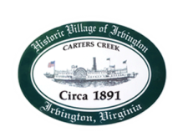
Town of Irvington Zoning Administrator Report
Prepared for Town Council
Prepared For: March 10th, 2022
Staff Contact: Justin Nelson, Zoning Administrator

Miscellaneous

Received additional receipts from Mr Fisher for more debris removal; site visit for tree removal complaint on Chase’s Cove Road; site visit for rebuilding of garage on Chase’s Cove Road (no permit filed yet) site visit for new home on Chesapeake Dr (no permit filed yet)
Convened the Board of Zoning Appeals for a hearing on a denied zoning permit application for an addition at 84 Rowe’s Point Road; BZA reversed the zoning administrator and approved the permit
Suggest a business registry be instituted for the Town, which is supported by Planning Commission if there is no fee

.

