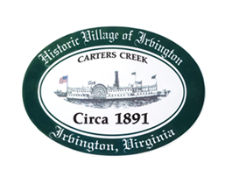

PLANNING COMMISSION SPECIAL CALLED MEETING
Tuesday, October 12, 2021, 6:30 P.M., Irvington Baptist Church

1. CALL TO ORDER - Julie Harris, Chair

2. ROLL CALL AND DETERMINATION OF QUORUM - Julie Harris, Chair

3. APPROVE MINUTES
- September 7, 2021 Regular Called Meeting

4. REPORT FROM CHAIR - Julie Harris

5. REPORT FROM ZONING ADMINISTRATOR- Justin Nelson

6. OLD BUSINESS

A. Update on proposals from consulting firms - B. Forrester, T. Chapman

B. Second Reading of Resolution for rezoning application #2021.RZ1 Pollard,
73 Seafood Lane, Irvington, Virginia to rezone from M-1 to B-1
- Discussion/Vote

C. Second Reading of Resolution for Conditional Use Permit #2021.CUP2 Pollard 73 Seafood Land, Irvington, Virginia for an Inn in B-1
- Discussion/Vote

7. NEW BUSINESS

A. First Reading of Mayhew CUP #2021.16 for construction of a pool in RPA of R-1 district using re-construction (site visit and two meeting with applicant)

8. NEXT MEETING:
- Joint Public Hearing of PC/TC, Thursday, October 14, 2021 at 6:30 p.m. at Irvington Baptist Church (CUP Mayhew – 1st reading)
- Planning Commission Special Called Meeting, Tuesday, November 9, 2021 at 6:30 at Irvington Baptist Church

9. ADJOURN

