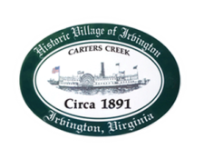
Town of Irvington Zoning Administrator Report
Prepared for Town Council
Prepared For: October 13th, 2022
Staff Contact: Justin Nelson, Zoning Administrator

Zoning Permits:

#2022-16, addition to Rowe’s Point home; #2022-17 replace pier on The Lane

Miscellaneous:
Additional receipts received from Mr. Fisher for removal of debris; site visit to Lancaster Rd for water run off; site visit to gas station for new signage, permit not applied for yet; site visit to new Camp which has officially opened; site visit for Café CUP before us; write up of policies and procedures for implementing STR ordinance, write up to amend sign ordinance to remove Council approval and replace with ZA approval if sign meets code requirements; write up fence ordinance for R-1/R-2

.

