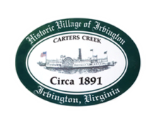
Town of Irvington Zoning Administrator Report
Prepared for Planning Commission & Town Council
Prepared For: March PC & TC Meetings
Staff Contact: Justin Nelson, Zoning Administrator

Zoning Permits:

#2023-5, parking lot expansion behind Dredge; 2023-6, pool house on King Carter Drive; 2023-7, dock on The Lane; 2023-8, garage expansion on Edgewood; 2023-9, new pool on Chases Cove.

Miscellaneous:
29 total STR’s now with two more applications pending; application noticed for RPA redevelopment has been rescheduled

.

