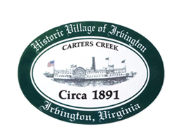

TOWN OF IRVINGTON, VIRGINIA
PLANNING COMMISSION WORKSHOP
Comprehensive Plan Survey,
Comprehensive Plan & Zoning Code Update
Irvington Town Office
4203 Irvington Road, Irvington, VA
Thursday, November 4, 2021, 7:30 P.M.

A. CALL TO ORDER - Julie Harris, Chair

B. ROLL CALL - Julie Harris, Chair

C. APPROVE AGENDA

D. DISCUSSION of development of Town Survey,
Revision of Comprehensive Plan & Zoning Code Update
- EPR-PC

E. ADJOURN

