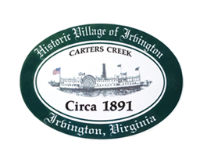

THE TOWN OF IRVINGTON

PLANNING COMMISSION REGULAR CALLED MEETING
Irvington Town Office, 4203 Irvington Rd., IRVINGTON, VA
TUESDAY, April 4, 2023; 6:30PM

Preliminary Agenda

- Call to Order – T. Chapman

- Roll Call and Determination of Quorum – T. Chapman

- Approve Minutes
- 3/7/2023 Minutes approval – T. Chapman

- Report From Chair- T. Chapman

- Public Comment

- Report from Zoning Administrator – Justin Nelson

- Old Business
a. CUP_HERNDON to operate a STR BUSINESS at 42 Steamboat Rd - J. Nelson
b. CUP_CRAB TRAP to operate a STR BUSINESS at 31 Spring Street – J. Nelson
c. Capital Improvement Plan – T. Chapman
d. Proposal and discussion for change in CUP requirement language – J. Nelson
e. General Discussion of Enforcement – J. Nelson

- New Business
  - Discussion of 154.052 (B) For lots containing or intended to contain a two-family dwelling the minimum lot area shall be one and one half acres. All lots of record prior to March 9 1989 shall be exempt from this requirement. A. Pollard Jr.
  - Consideration of three way stop sign on RT 200 and King Carter Dr. - A. Pollard Jr.

- Next meeting
May 2, PC Regularly Scheduled Meeting at Irvington Town Hall, 6:30 p.m.

- Adjourn

