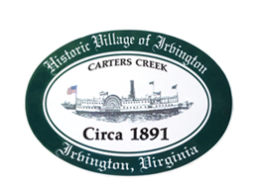

THE TOWN OF IRVINGTON
PLANNING COMMISSION SPECIAL CALLED MEETING
IRVINGTON BAPTIST CHURCH, IRVINGTON, VA
TUESDAY, September 27, 2022; 6:30PM

Preliminary Agenda

- Call to order – Tom Chapman

- Roll Call and Determination of Quorum- T. Chapman

- Public Comment

- Old Business
- Tides Inn CUP Discussion and Action – all

- Next meeting
Oct. 4, 2022, at Irvington Baptist Church, 6:30 p.m.

6. Adjourn

