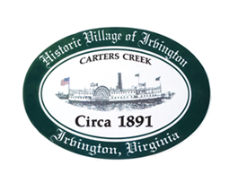
TOWN OF IRVINGTON, VIRGINIA - continuation of May 12, 2022, meeting
TOWN COUNCIL REGULAR CALLED MEETING
Irvington United Methodist Church
Thursday, May 16, 2022; 6:00 p.m.

AGENDA
- CALL TO ORDER

- ROLL CALL

- APPROVE AGENDA

- REPORT FROM SEWER PANEL
- Discussion

- REPORT FROM PLANNING COMMISSION
- Discussion of Town Survey

- ADJOURN

