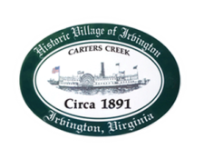
Town of Irvington Zoning Administrator Report
Prepared for Town Council
Prepared For: December 7th 2021
Staff Contact: Justin Nelson, Zoning Administrator

Zoning Permits:

#2021-25 New home on Chesapeake Drive; #2021-26 new dock on York Road; #2021-27 Tides Inn stair case replacement

Applications:

Second reading of Mayhew CUP2021_03Mayhew for construction of a pool in RPA of R-1 district using re-construction (site visit and two meetings with applicant)

Miscellaneous:
Additional receipts received from Mr Fisher for removal of debris; Keene Law has sent a letter to all parties involved with Fisher’s Pit (enclosed)
Bay Design has additional questions/funds needed to proceed on town building (enclosed)
.

