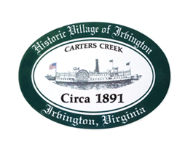
RESOLUTION 2021-16 PC
Conditional Use Permit Application-Build Pool Inside RPA, R-1, Tax Map 34 Parcel 10F
WHEREAS, the Irvington Planning Commission reviewed a Proposed Conditional Use Permit (CUP) Application # 2021_CUP03Mayhew to build a new pool at a residence inside the RPA, redevelopment, no further encroachment and no increase in impervious cover, in R-1 zoning district, Tax Map #34 Parcel 10F, at 336 Old Mill Cove Road (“Application”); and
WHEREAS, a joint public hearing on the Application was advertised in the Rappahannock Record on September 30th and October 7th, 2021; and

WHEREAS, the Planning Commission and Town Council held a joint public hearing on October 12th to hear public views on the Application; and

WHEREAS, the Planning Commission considered the Application at its meetings on October 12th and November 9th, 2021; and

WHEREAS, Town Council considered the Application at its meetings held on October 12th and November 11th, 2021.

NOW THEREFORE, BE IT RESOLVED that the Irvington Planning Commission hereby approves the Application subject to the following conditions: _____________. (Either state the conditions or indicate there are no conditions.)
Certification
I, Phil Robinson, Secretary, do hereby certify that the above is a true copy of Resolution 2021-16 PC adopted at a meeting of the Irvington Planning Commission held on November 9th, 2021, at which a quorum was present and voting. The vote was:
In favor Opposed Absent

IRVINGTON PLANNING COMMISSION
_____________________________________,
Phil Robinson, Secretary

