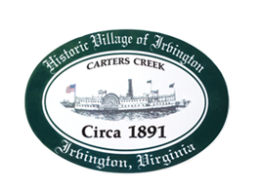
RESOLUTION 2021-11TC
Rezoning Application - Rezone from M-1 to B-1 Tax Map 33.379
WHEREAS, the Irvington Town Council reviewed a Proposed Rezoning Application from M-1 to B-1, Rezoning Application 2021.RZ1 Pollard Tax map # 33.379 located at 73 Seafood Lane (“Application”); and
WHEREAS, a joint public hearing was advertised in the Rappahannock Record on September 30, 2021 and October 7, 2021; and

WHEREAS, the Planning Commission considered the Application at its meetings held on September 7, 2021 and October 12, 2021; and

WHEREAS, the Planning Commission and Town Council held a joint Public Hearing on October 12, 2021 to hear public views on the Application.

WHEREAS, the Town Council considered the Application at its meetings held on September 9, 2021 and October 14, 2021; and

NOW THEREFORE, BE IT RESOLVED that the Irvington Town Council hereby approves the Application subject to the following conditions: __________________. (Either state the conditions or indicate there are no conditions.)

I, Frances E. Westbrook, Interim Mayor, do hereby certify that the above is a true copy of Resolution 2021-11TC adopted at a meeting of the Irvington Town Council of Irvington, Irvington, Virginia held on October 14, 2021, at which a quorum was present and voting. The vote was:
Reasons given, if any: ____________________________________________________.
In favor Opposed Absent

IRVINGTON Town Council
_____________________________________,
Frances E. Westbrook, Interim Mayor

