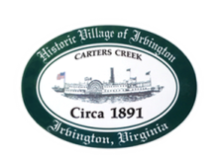
Town of Irvington Zoning Administrator Report
Prepared for Town Council
Prepared For: May 12th, 2022
Staff Contact: Justin Nelson, Zoning Administrator

Miscellaneous

Received additional receipts from Mr Fisher for more debris removal; sidewalk inspection to determine what needs replacing; have reached out to VDOT for approval for installation of new sidewalks; site visit for signs for new retail store; completed first in person DEQ audit on 4/14, second phase will be May24th.

Application

Received sign application for Refuel, in your packet for a vote
.

.

