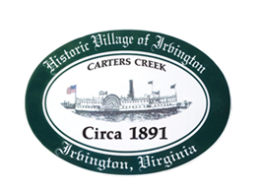

THE TOWN OF IRVINGTON

PLANNING COMMISSION REGULAR CALLED MEETING
TOWN OFFICE, 4203 IRVINGTON RD, IRVINGTON, VA
TUESDAY, NOVEMBER 1, 2022; 6:30PM

Preliminary Agenda

PUBLIC HEARING ON STR CUPs for: Stephens, 416 Steamboat Rd; Baker, 125 Edgewood Ln; and Landers, 89 Park Place

- Call to order – Tom Chapman

- Roll Call and Determination of Quorum- T. Chapman

- CUP readings – J. Nelson

- PUBLIC COMMENT

- ADJOURN

REGULARLY SCHEDULED MEETING OF IRVINGTON PLANNING COMMISSION
- Call to Order – T. Chapman

- Roll Call and Determination of Quorum – T.Chapman

- Approve Minutes
- 10/4/2022 Minutes approval – T. Chapman

- Report From Chair- T. Chapman

- Public Comment

- Report from Zoning Administrator – Justin Nelson

- Old Business
- Pollard CUP Action
- STR Allowable numbers – J. Taylor

- New Business
    - Stephens STR, CUP action
    - Baker STR, CUP action
    - Landers STR CUP action

- Closed Session on EPRpc Proposal

- Vote on EPRpc Proposal

- Next meeting
Dec 6 , 2022, at the Irvington Town Hall, 6:30 p.m.

- Adjourn

