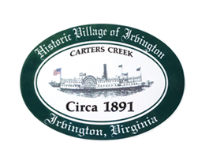
RESOLUTION 2022-17 TC
Renaming of Point of Land at end of Steamboat Road
WHEREAS, the Irvington Town Council reviewed a request to rename this point of land in honor of Bob Lee and Suzy Stephens, and
WHEREAS, the Town Council recognizes the important and large impact Bob Lee and Suzy Stephens had on the Town of Irvington and it’s nature, and

WHEREAS, the Town Council agrees to this honorary renaming,

NOW THEREFORE, BE IT RESOLVED that the Irvington Town Council hereby approves the renaming of the Point of Land at the end of Steamboat Road to Stephens Point
Certification
I, Julie Harris, Mayor, do hereby certify that the above is a true copy of Resolution 2022-17 TC adopted at a meeting of the Irvington Town Council held on May 12th, 2022, at which a quorum was present and voting. The vote was:
In favor Opposed Absent

TOWN OF IRVINGTON
_____________________________________,
Julie Harris, Mayor

