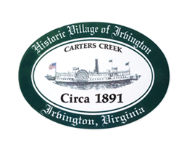

THE TOWN OF IRVINGTON
PLANNING COMMISSION SPECIAL CALLED MEETING
IRVINGTON BAPTIST CHURCH
THURSDAY, NOVEMBER 9, 2021; 6:30PM

- Call to order - Julie Harris, Chair

- Roll Call and Determination of Quorum- Julie Harris, Chair

3. Approve Minutes
- October 12, 2021

- Report from Chair – Julie Harris

- Report from Zoning Administrator – Justin Nelson

- Old Business
- Second Reading of Mayhew CUP #2021.16 PC for construction of a pool in RPA, R-1 using re-construction
- Discussion / vote
- Review of workshop interviews with Berkley Group / EPR-PC
- Discussion / vote

- New Business
- Moving from 5 to 3 meetings for CUPs – J. Nelson
- Discussion / vote

8. Next meeting
- Special Called Meeting, Tuesday, December 14, 2021 at 6:30 at Irvington Baptist Church.

9. Adjourn

