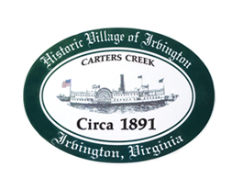

THE TOWN OF IRVINGTON
PLANNING COMMISSION REGULAR CALLED MEETING
IRVINGTON BAPTIST CHURCH, IRVINGTON, VA
TUESDAY, October 4, 2022; about 6:30PM ( but immediately following STR Workshop)

Preliminary Agenda

- Call to order – Tom Chapman

- Roll Call and Determination of Quorum- T. Chapman

3. Approve Minutes
- 9/6/2022 Minutes approval – T. Chapman

- Report from Chair – T. Chapman

- Public Comment

- Report from Zoning Administrator – Justin Nelson
- Monthly Report

- Old Business
- Survey Results review- All
- Survey next steps– All
Key issue is what further work do we want from EPRpc
- Key issues for Comprehensive Plan Update
- Continued Reading of and Use Ordinance (as time allows) – Al Pollard Jr.

- New Business

- Next meeting
Nov 1, 2022, at the Irvington Town Hall, 6:30 p.m.
9. Adjourn

