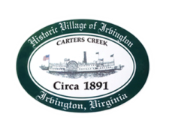
Town of Irvington Zoning Administrator Report
Prepared for Town Council
Prepared For: January 13th, 2022
Staff Contact: Justin Nelson, Zoning Administrator

Zoning Permits:

#2021-29 addition to existing home; 2022-01 for new deck; 2022-02 for addition to home

Miscellaneous:
Additional receipts received from Mr Fisher for removal of debris; dangerous tree on Virginia street (site visit) Meeting w/PC CUP committee on reviewing CUP process, which is ongoing. Survey of business’ interest/objection to ABC license for Town Event (visited 8 businesses; spoke on phone w/3 additional, including Tides Inn) no objections; assemble Zoning appeals board for upcoming zoning appeal application, site visit to applicant; visit pink house garage

.

